Week 12

Project: Kafka + Spark Streaming + PySpark

**___________________________________________________________________**

**Kafka QuickStart — Apache Kafka + Kafka-Python**

1.The latest version of Kafka binary distribution is available at <https://kafka.apache.org/downloads.>

2. Starting Zookeeper. Unzip it, get into the folders cd into it

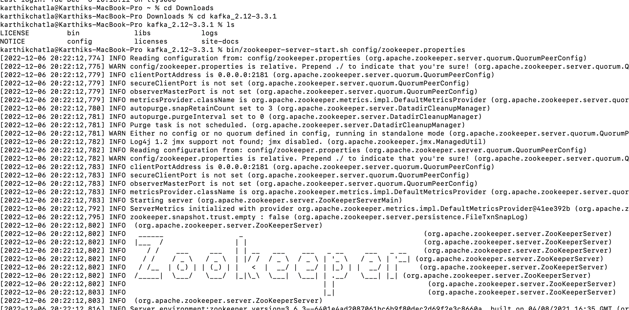

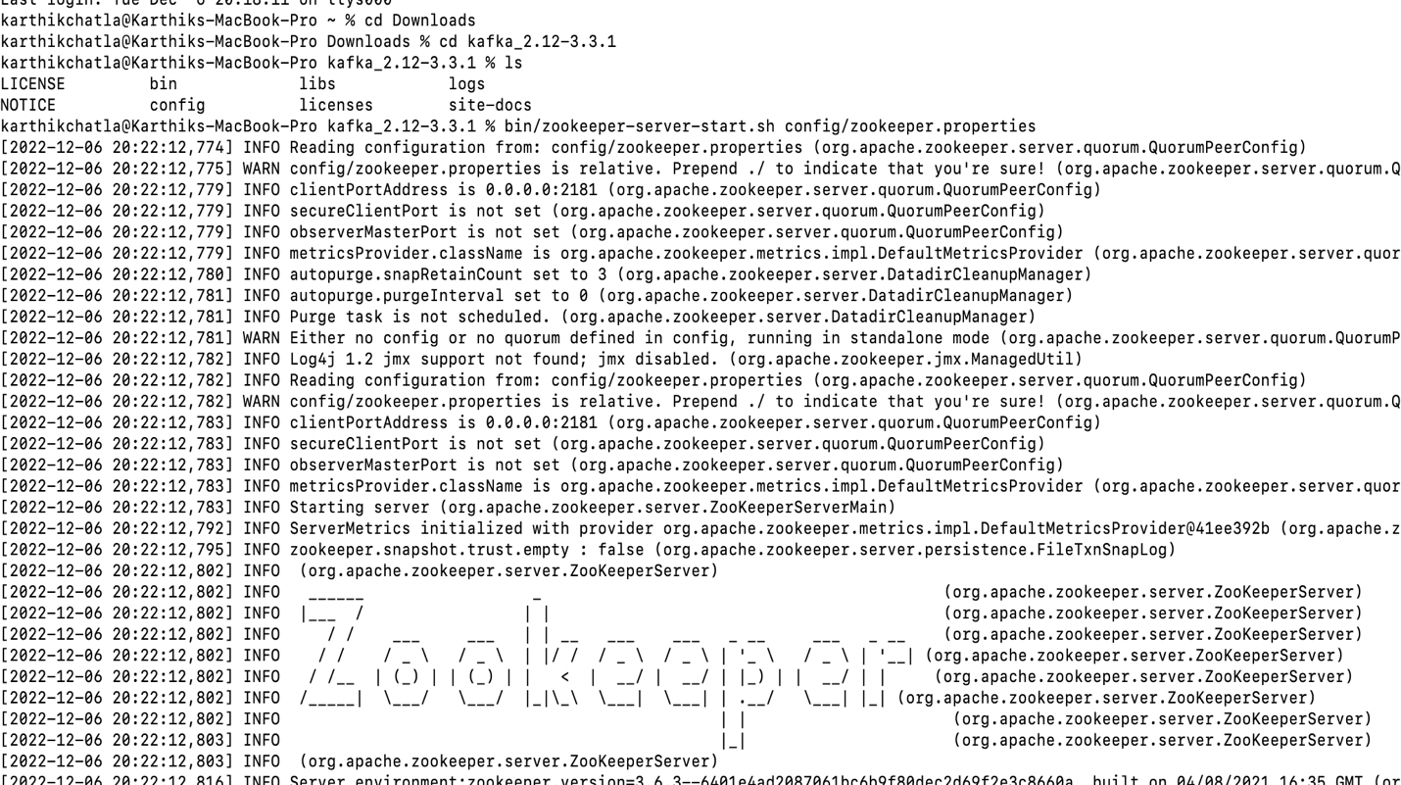

3. Starting Kafka Brokers

Create another terminal, do not close zookeeper

**4.Creating Kafka Topics.**

**Create another terminal, do not close zookeeper and kafka brokers**

**bin/kafka-topics.sh --create --topic input_recommend_product --zookeeper localhost:2181 -- partitions 3 --replication-factor 1**

Meet with problem. Solve it : <https://stackoverflow.com/questions/69297020/exception-inthread-main-joptsimple-unrecognizedoptionexception-zookeeper-is>

bin/kafka-topics.sh --create --topic input_recommend_product --bootstrap-server localhost:9092 --partitions 3 --replication-factor 1

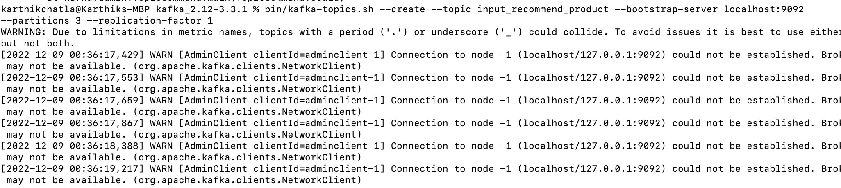

To see the topics: bin/kafka-topics.sh --bootstrap-server localhost:9092 –list

5 Creating Producer and Consumer using Kafka-python

5.1 Create producer.py

from kafka import KafkaProducer

producer = KafkaProducer(bootstrap_servers='localhost:9092')

producer.send('input_recommend_product', b'(1, Main Menu), (2, Phone) ,(3, Smart Phone), (4, iPhone)')

producer.close()

5.2 Create Consumerr.py

Code

from kafka import KafkaConsumer

consumer = KafkaConsumer('input_recommend_product',

bootstrap_servers=['localhost:9092'])

for msg in consumer:

print(msg)

5.3 Run comsumer.py first (you can run it in your IDE)

5.4 Create another terminal, run the producer.py

5.5 Go to the consumer terminal, you can see the result